Exercise 1

* **What’s the name of the relation?:** weather.nominal
* **Number of Records**: There are 14 records in the dataset.
* **Number of Instances**: Each dataset has 14 instances.
* **Number of Attributes**: There are 5 attributes: outlook, temperature, humidity, windy, and play.
* **List Attribute Names and Types**:
  + outlook: Nominal (sunny, overcast, rainy)
  + temperature: Nominal (hot, mild, cool)
  + humidity: Nominal (high, normal)
  + windy: Nominal (TRUE, FALSE)
  + play: Nominal (yes, no)
* **Values for Each Attribute**: You can observe the values for each attribute based on their types (nominal values provided).
* **Missing Values**: Based on the provided data, there are no missing values.
* **Distinct Values**: You can count the distinct values for each attribute.
* **Unique Values**: Identify instances where an attribute has a value that no other instances have.
* **Basic Statistics**:
  + For categorical attributes (outlook, temperature, humidity, windy, play), show the frequency of each attribute.
  + For continuous attributes (not present in this dataset), you can show the value of min, max, mean, standard deviation, etc.
  + Class Attribute: The class attribute in this case is "play," and it has two classes: "yes" and "no."
* Identify the Class Attribute: The class attribute in this dataset is "play."
* Determine the Number of Records for Each Class:
  + Count the occurrences of each class ("yes" and "no") in the "play" attribute:
    - "yes": 9 records
    - "no": 5 records
* Plot Histogram:

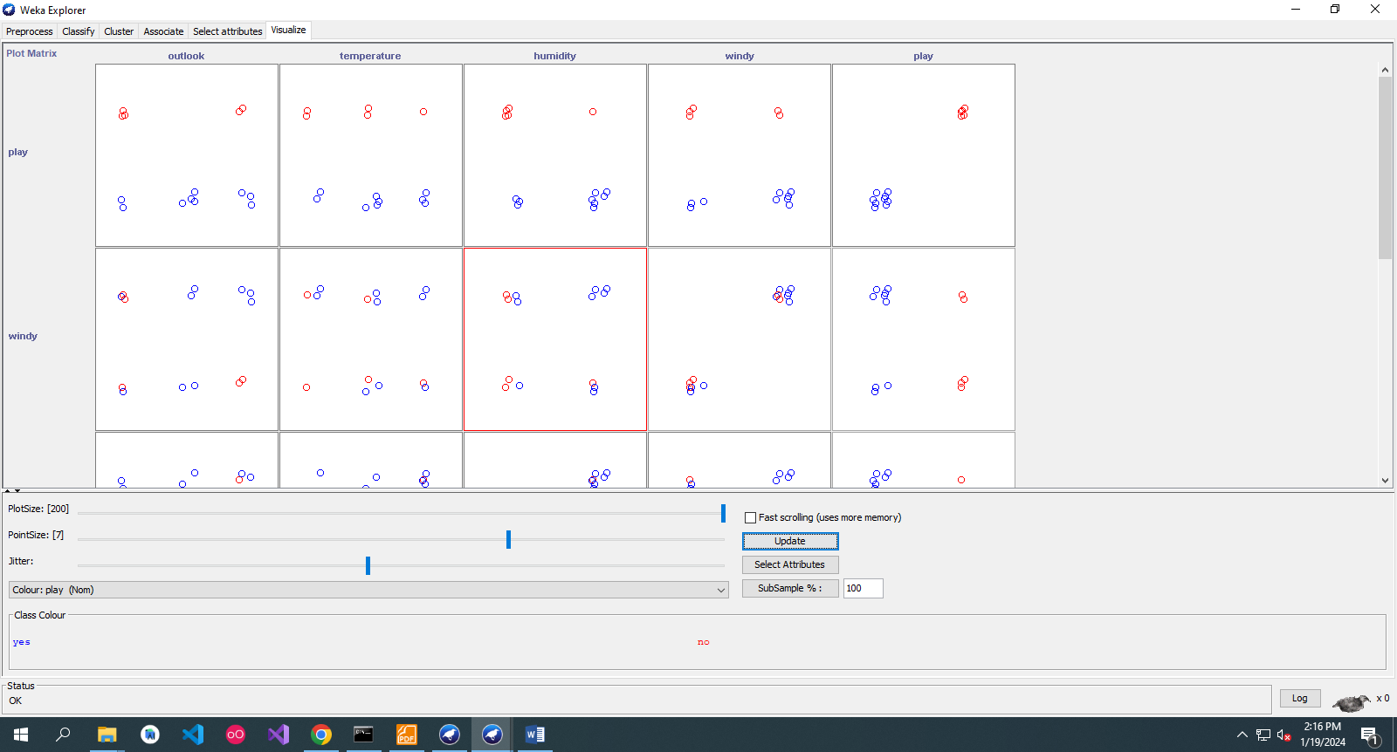

* Visualize Data in Various Dimensions:

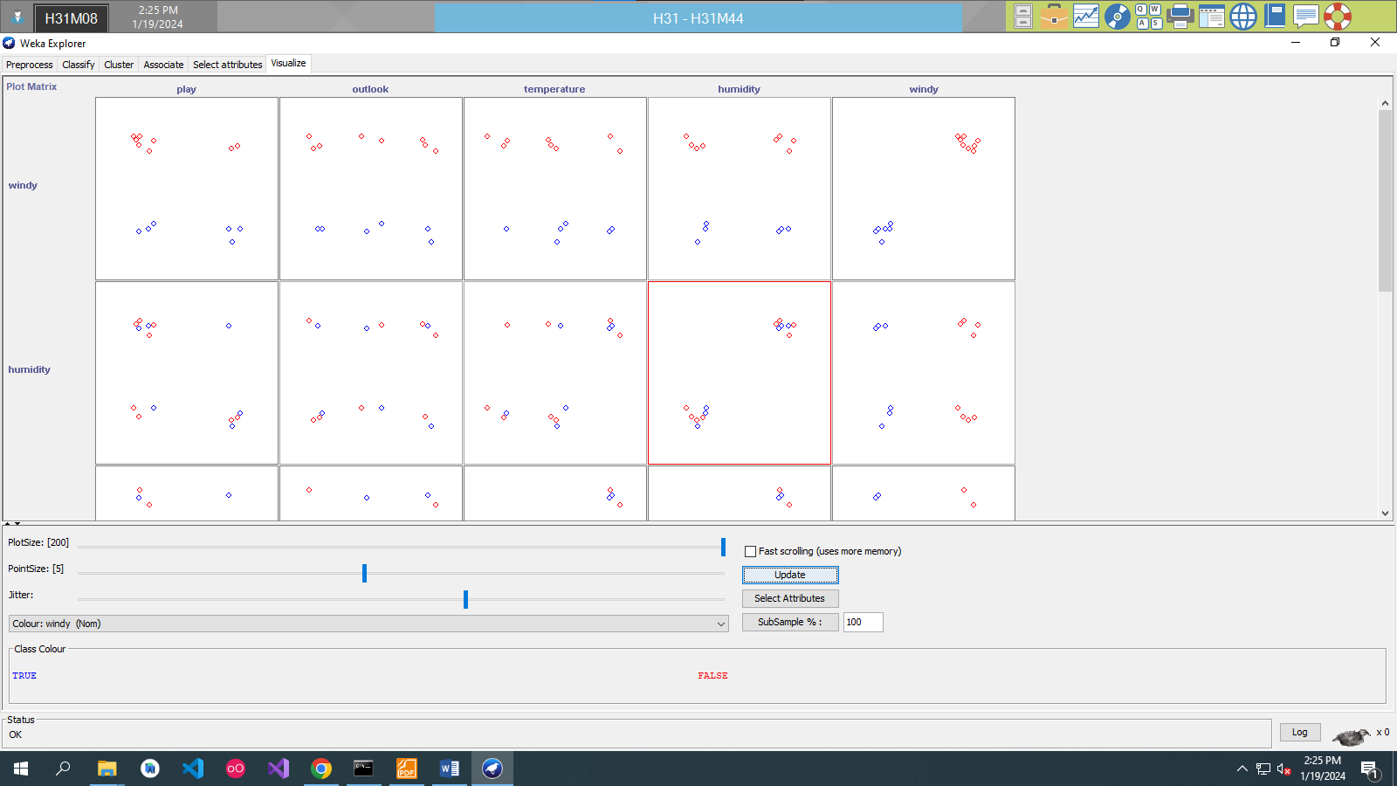

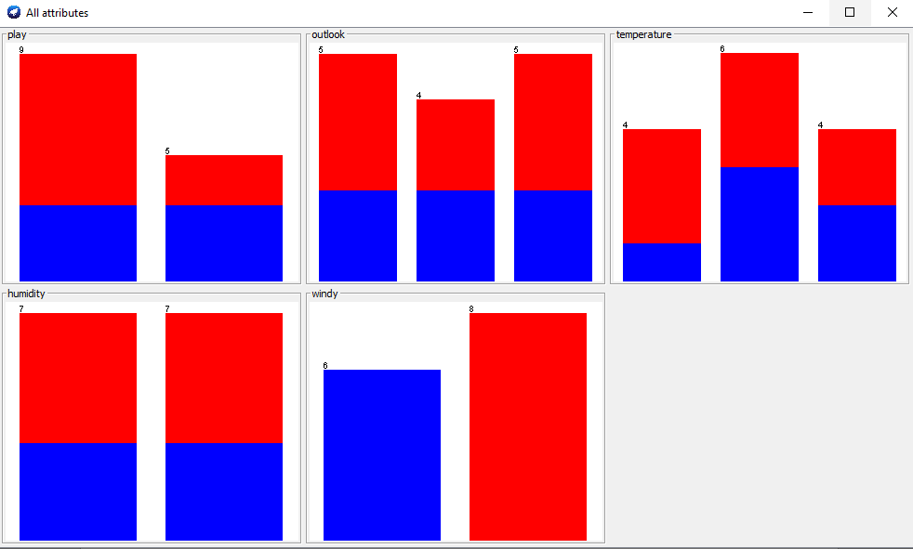

* Comparison of Visualizations:

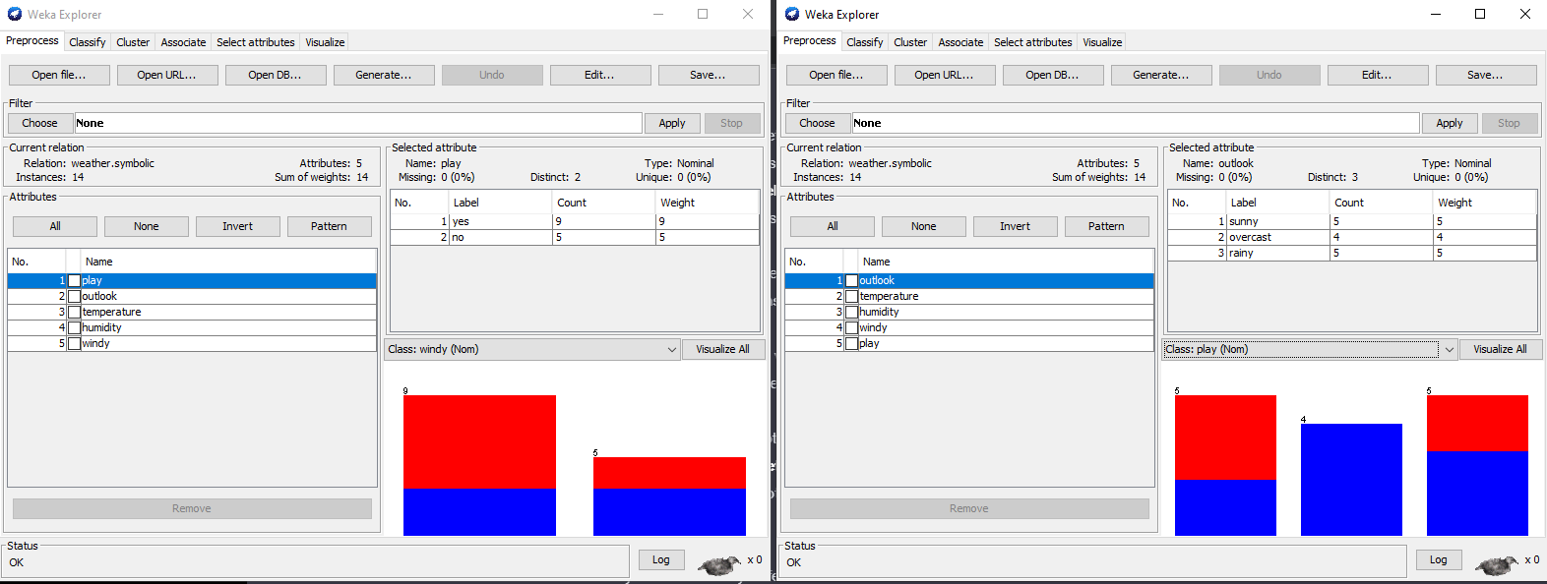

The only thing that I notice is histogram show-up, the dataset (where the class attribute is at the first column) which Histogram Visualize is the Class: windy and the dataset (where the class attribute is at the last column) which Histogram Visualize is the Class: play.